

ASSIGNMENT 2
QUESTIONS

CO2: Analyze public-key cryptosystem strategies using RSA and key exchange for encryption algorithms to strengthen information security.
CO2 Coverage: Symmetric key cryptosystems; Data Encryption Standard (DES); Triple DES (3DES); Blowfish; RC5; block ciphers; stream ciphers; block cipher modes of operation; public-key cryptosystems; RSA algorithm; key distribution and management; Diffie–Hellman key exchange; elliptic curve cryptography (ECC); introduction to quantum cryptography; number-theory foundations; RSA attacks and padding; digital signatures; hybrid encryption.
Assignment Title: Evaluate, Design and Defend a Secure Public-Key and Hybrid Cryptographic Strategy for a Multi-Site Healthcare Network (Total Marks: 50)

Scenario — Secure Healthcare Data Exchange
A healthcare network connects one central hospital with remote clinics that exchange patient records, prescriptions, diagnostic reports and billing data over public networks. The network contains low-resource devices, high-volume file transfers and multiple security requirements. The security team must select appropriate symmetric and public-key techniques, establish keys securely, authenticate exchanges and prepare for long-term cryptographic migration.

The system must:
- Protect stored and transmitted clinical records with confidentiality.
- Establish session keys over an observable public network.
- Provide authentication and integrity for security-sensitive exchanges.
- Support large files without performing expensive public-key encryption on every data block.
- Remain practical for constrained clinics while allowing secure migration as threats and technology change.

Design Challenge
During peak operation the network expands to many remote sites. An attacker can observe traffic, attempt a man-in-the-middle attack during unauthenticated key exchange, exploit weak RSA parameters, and analyse repeated ciphertext patterns. Management also requires a migration plan for future quantum threats. Re-evaluate the original design using your mathematical and experimental evidence.

Q1 – Symmetric Cryptosystem Selection and Modes of Operation (7 Marks)
Problem Context – Protecting Clinical Records
The network must compare classical symmetric choices before using public-key techniques. Evaluate DES, 3DES, Blowfish and RC5, together with the distinction between block and stream ciphers and the principal block-cipher modes.

Your Challenge
- Explain the structure, block size, key characteristics and round operation of DES, 3DES, Blowfish and RC5.
- Implement or simulate at least three of these algorithms on student-created test data and verify encryption/decryption.
- Explain the difference between block and stream ciphers and identify an appropriate use for each.
- Explain ECB, CBC, CFB, OFB and CTR, including IV/nonce requirements, pattern leakage, error propagation and parallelism.
- Demonstrate why ECB can reveal repeated plaintext patterns and why IV/nonce reuse is dangerous.
- Compare operation count and execution time for increasing message sizes.

Evaluation
Rank DES, 3DES, Blowfish and RC5 for the scenario, identify legacy limitations, and recommend where a block or stream construction would be appropriate. Do not treat a larger key space alone as proof of security.
Evidence Expected: Algorithm comparison, mode comparison, test results, pattern/IV demonstration and a justified recommendation.

Q2 – Number-Theory Engine and Prime Selection for RSA (6 Marks)

Problem Context – RSA Key Generation
RSA depends on modular arithmetic, modular inverses, modular exponentiation and the generation of suitable primes.

Your Challenge
- Implement GCD, Extended Euclidean Algorithm, modular inverse and fast modular exponentiation.
- Compare trial-search inverse with Extended Euclid and naive repeated multiplication with square-and-multiply.
- Explain Euler’s totient function and the condition gcd(e, φ(n)) = 1.
- Compare trial division, Fermat and Miller–Rabin on safe toy candidates, including Carmichael numbers such as 561, 1105 and 1729.
- Record modular multiplications, division/loop steps and false acceptance results.
- Explain how prime density affects the number of candidates tested.
- Re-evaluate the methods when the RSA modulus grows from classroom-sized values toward 1024-, 2048- and 3072-bit engineering requirements.
Evidence Expected: Mathematical derivations, pseudocode, designed test cases, operation counts, primality-test evidence and engineering decision.

Q3 – RSA Encryption/Decryption, Weaknesses and Padding (7 Marks)
Problem Context – Online Banking Message Protection
A bank uses textbook RSA for short tokens. The security team must determine whether correct decryption is sufficient evidence of secure encryption.

Your Challenge
- Generate RSA keys and implement C = M^e mod n and M = C^d mod n.
- Verify one hand-checkable RSA example.
- Test deterministic encryption, repeated-message encryption, small-message/small-exponent behaviour, boundary messages and invalid parameter choices.
- Explain how factoring n permits recovery of φ(n) and d.
- Implement or simulate trial-division and Fermat factorisation on weak toy moduli, including close primes and a small factor.
- Explain why RSA key length alone does not guarantee security and why weak key generation can undermine a large modulus.

- Explain RSA padding, especially OAEP, and how randomisation prevents structural weaknesses of textbook RSA.

Inquiry
Predict each test before execution, compare prediction with evidence, and state the limitations of classroom-scale factoring experiments.
Evidence Expected: Correct RSA implementation, attack traces, factoring evidence, padding analysis and security conclusions.

Q4 – Diffie–Hellman Key Exchange, Authentication and Key Management (7 Marks)
Problem Context – Secure Link Between Remote Clinics
Two clinics must establish a shared session key over a network that an attacker can fully observe, without having a pre-shared secret.

Your Challenge
- Derive the Diffie–Hellman procedure from (g^a)^b ≡ (g^b)^a (mod p).
- Develop pseudocode showing private values, public values and the shared-key computation.
- Test a small hand-verifiable example and a larger toy configuration.
- Measure the legitimate computation and a brute-force discrete-log attack as p grows.
- Demonstrate an active man-in-the-middle attack against unauthenticated Diffie–Hellman.
- Explain how digital signatures or certificates authenticate the exchanged values and defeat the attack.
- Design a key-distribution and key-management policy covering generation, storage, rotation, revocation, compromise recovery and session-key lifetime.
Evidence Expected: Protocol derivation, message-sequence diagram, implementation, MITM demonstration, growth analysis and key-management policy.

Q5 – ECC and Public-Key Strategy Comparison (5 Marks) Problem Context – Constrained Devices
Remote medical devices need public-key security with manageable key size, computation and communication overhead.

Your Challenge

- Explain the mathematical basis of elliptic-curve public-key

cryptography and demonstrate a toy ECC key-generation/key-agreement example.
- Compare RSA, Diffie–Hellman and ECC in key size, computational cost, bandwidth and deployment considerations.
- Explain why ECC can provide comparable security with smaller public-key material than traditional RSA-style parameters.
- Identify implementation requirements such as secure randomness, parameter validation and protected private keys.
- Recommend a public-key strategy for constrained devices and justify it using the experimental evidence from Q2–Q4.
Evidence Expected: Toy ECC example, RSA/DH/ECC comparison table and a defended recommendation.

Q6 – Digital Signatures, Hybrid Encryption and Quantum-Cryptography Readiness (7 Marks)
Problem Context – Large Confidential Document Exchange
The healthcare network must transfer large files with confidentiality, integrity and sender authenticity. The team is comparing direct public-key protection with hybrid encryption and must also consider future quantum threats.

Your Challenge
- Design a digital-signature process using hash-then-sign and explain signing and verification.
- Compare RSA, DSA/DSS and ECDSA at the conceptual level with respect to keys, signing/verification, randomness and security assumptions.
- Design hybrid encryption: encrypt the large payload with a random symmetric session key, then protect or establish that session key using RSA or Diffie–Hellman; authenticate the exchange.
- Test tampering of the file, signature and protected session key.
- Compare direct RSA encryption of large data with hybrid encryption using operation counts and file-size growth.
- Explain the basic principle of quantum key distribution/quantum cryptography and how eavesdropping can be detected.
- Explain why sufficiently capable quantum computers threaten RSA and ECC and propose a migration/readiness strategy without claiming that quantum cryptography itself replaces ordinary cryptographic key management.

Deployment Decision
Choose a practical architecture for the healthcare network and justify the

choice using performance, security, key-management burden and long-term risk.
Evidence Expected: Signature flow, hybrid-encryption design, tamper tests, growth comparison, quantum-security explanation and final architecture.

DAY-4 DESIGN CHALLENGE

Q7 – Diagnose, Redesign and Validate the Complete Cryptographic Strategy (11 Marks)
Review the evidence from Q1–Q6 and identify one significant computational or security limitation that becomes important as message volume, key size, number of clinics or attacker capability increases.

Diagnose the Bottleneck or Weakness (2 Marks)
- Identify the operation or missing security property responsible for the limitation.
- Explain how its cost or risk changes with input/key size or repeated use.
- Use measured operation counts or attack evidence from earlier tasks.

Define the Design Objective (1 Mark)

State a measurable redesign objective, such as reducing public-key operations, preventing a man-in-the-middle, reducing key-management exposure, detecting weak keys, or improving secure bulk-data handling.

Design the Revised Strategy (3 Marks)
Develop a revised architecture using the appropriate combination of symmetric encryption, secure modes, RSA/DH/ECC, digital signatures, key management and hybrid encryption. Explain the mathematical/security property exploited, operations reduced, additional state or keys required, and new trade-offs.

Integrate Quantum Readiness (1 Mark)
Identify which RSA/ECC dependencies are threatened by future quantum computing and define a migration approach. Explain separately what quantum key distribution can contribute and what it cannot replace.

Predict, Implement and Validate (2 Marks)
Predict the improvement before implementation. Compare original and redesigned solutions using operation counts, attack steps, key-management events, verification results and execution time where useful.

Verify that the redesign preserves required functionality.

Defend the Final Design (2 Marks)
Defend the final decision against the original alternatives. Discuss residual risks, deployment cost, usability, key compromise, MITM attacks, weak keys, large-file performance and long-term quantum risk.
Evidence Expected: Diagnosis, measurable objective, revised architecture/protocol, prediction, comparable experimental evidence and final engineering defence.

MARK DISTRIBUTION

Question | Assessed Area | Marks
Q1 | Symmetric cryptosystems, DES/3DES/Blowfish/RC5, block/stream ciphers and modes | 7
Q2 | Number theory, modular arithmetic and prime selection | 6
Q3 | RSA encryption/decryption, attacks, weak keys and padding | 7
Q4 | Diffie–Hellman, MITM authentication and key management | 7
Q5 | ECC and RSA/DH/ECC comparison | 5
Q6 | Digital signatures, hybrid encryption and quantum readiness | 7
Q7 | Day-4 integrated diagnose, redesign and validation | 11
TOTAL |  | 50

Submission Requirements
Submit your assignment report containing Q1–Q7 evidence, source code for student-implemented core algorithms, raw experimental data, tables/graphs and protocol/message-sequence diagrams. Libraries may be used for cross-checking standard primitives, but the mathematical core and experiments must be your own.

All attack demonstrations must use only student-created toy parameters and test data. Do not use classroom code to protect real patient data.

Assessment Verification
Students may be asked to explain algorithm design, source code, test data, mathematical predictions, experimental results, security analysis and the Day-4 redesign during a brief verification/viva. Both the reasoning and the evidence must be understood by the student.
- Algorithmic and protocol design
- Source code
- Test-data and key-set design
- Experimental results
- Predictions
- Security analysis
- Design Challenge
during a brief verification discussion/viva. The student should therefore be able to explain and defend the evidence submitted as their own work.

Overall Assessment Expectation
This assignment does not primarily assess your ability to reproduce textbook cryptosystems.
It assesses your ability to:
Predict → Design → Implement → Measure → Analyse → Attack → Evaluate → Diagnose → Redesign → Validate
Your conclusions and design decisions must be supported by your own mathematical reasoning and experimental evidence.

Q1. Symmetric Cryptosystem Selection and Modes of Operation
1. Introduction
Symmetric encryption uses the same secret key for encryption and decryption. It is suitable for protecting large amounts of healthcare data because it is fast.
2. Comparison of DES, 3DES, Blowfish and RC5
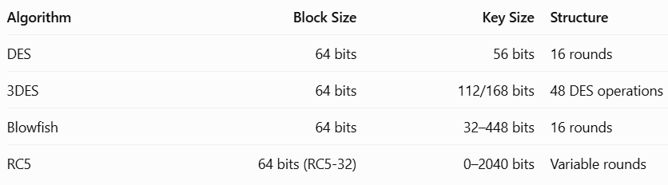DES: Uses a Feistel structure with 16 rounds. It is insecure because its key is too short.
- 3DES: Applies DES three times. It is stronger than DES but slow and outdated.
- Blowfish: Uses a Feistel structure and 16 rounds. It is suitable for older systems but has a 64-bit block size.
- RC5: Uses data-dependent rotations, XOR and addition. Its block size, key size and number of rounds are adjustable.
3. Block Cipher and Stream Cipher
Block Cipher | Stream Cipher
Encrypts fixed-size blocks. | Encrypts data bit by bit or byte by byte.
Suitable for files and records. | Suitable for continuous data streams.
Example: DES, AES. | Example: ChaCha20.
Use: Block ciphers are suitable for medical reports and files. Stream ciphers are useful for continuous communication between medical devices.
4. Modes of Operation
Mode | Explanation | Main Feature
ECB | Encrypts each block separately. | Reveals repeated patterns.
CBC | Each block depends on the previous ciphertext block. | Requires a unique, unpredictable IV.
CFB | Uses block cipher output to encrypt data like a stream. | Supports smaller data units.
OFB | Generates a keystream for encryption. | Transmission errors do not spread across later blocks.
CTR | Uses encrypted counter values. | Fast and supports parallel processing.
IV/Nonce: An IV or nonce is an initialization value used by certain encryption modes. It must follow the mode's uniqueness or unpredictability requirements.
5. Why ECB Is Dangerous
ECB encrypts identical plaintext blocks into identical ciphertext blocks. Therefore, repeated patterns can be identified by attackers.
For example:
- Plaintext: AAAAAAAA AAAAAAAA
- Ciphertext: XXXXXX XXXXXX
Repeated blocks produce repeated ciphertext blocks.
Reusing a nonce in CTR mode can expose relationships between plaintext messages and seriously weaken security.
6. Performance Comparison
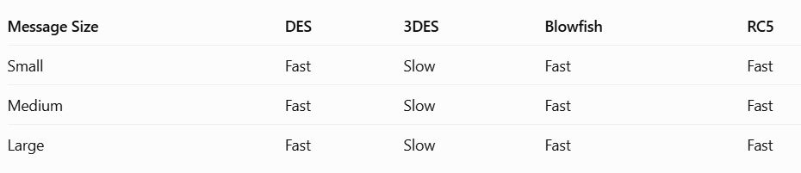These are qualitative expectations, not measured timings. Actual performance depends on implementation and hardware.
7. Recommendation
For the healthcare network, modern authenticated encryption such as AES-GCM or ChaCha20-Poly1305 is recommended instead of DES, 3DES, Blowfish or RC5. They provide confidentiality and integrity when correctly implemented.
Result: Symmetric encryption is suitable for large healthcare files because it provides fast and efficient data protection.

Q2. Number-Theory Engine and Prime Selection for RSA
1. Introduction
RSA uses number theory, prime numbers and modular arithmetic. It depends on finding large prime numbers and calculating modular inverses.
2. Important Mathematical Operations
GCD: Greatest Common Divisor is the largest number that divides two numbers.
Example:
[ GCD(12,18)=6 ]
Extended Euclidean Algorithm: It finds integers x and y such that:
[ ax+by=GCD(a,b) ]
Modular Inverse:
[ a . x =1 mod m ]
Example:
[ 3^{-1}mod {11}=4 ]
Because:
[ 3.4=12 =1 mod{11} ]
Modular Exponentiation:
[ a^b mod m ]
It calculates large powers using smaller operations.
3. Euler's Totient Function
Euler's totient function counts positive integers less than n that are relatively prime to n.
For RSA:
[ n=p. q ]
[ φ (n)=(p-1)(q-1) ]
The public exponent e must satisfy:
[ GCD(e,\ φ (n))=1 ]
4. RSA Prime Selection Methods
Method | Explanation
Trial Division | Checks divisibility by smaller numbers.
Fermat Test | Checks whether a number satisfies Fermat's theorem.
Miller–Rabin | Uses repeated mathematical tests to identify probable primes.
Miller–Rabin is more suitable for large prime candidates.
5. Carmichael Numbers
Carmichael numbers are composite numbers that can pass Fermat's primality test for certain bases.
Examples:
- 561
- 1105
- 1729
Therefore, Fermat testing alone is not sufficient for reliable prime selection.
6. Prime Density
Prime density decreases as numbers become larger. Therefore, more candidates may need to be tested to find a suitable large prime.
7. RSA Key Size Comparison
Key Size | Security
1024 bits | Not recommended
2048 bits | Common minimum modern RSA deployment size
3072 bits | Provides a higher security margin
8. Recommendation
Use Miller–Rabin testing with secure random number generation to select RSA prime numbers. Use Extended Euclidean Algorithm to calculate modular inverses efficiently.
Result: Number-theory operations help generate valid RSA keys and improve the security of encryption.

Q3. RSA Encryption/Decryption, Weaknesses and Padding
1. Introduction
RSA is an asymmetric encryption algorithm. It uses two keys:
- Public key – Used for encryption.
- Private key – Used for decryption.
2. RSA Key Generation
Steps:
- Select two prime numbers p and q.
- Calculate n = p × q.
- Calculate φ(n) = (p−1)(q−1).
- Select public exponent e.
- Calculate private exponent d.
[ d=e^{-1}mod{φ (n)} ]
3. RSA Encryption and Decryption
Encryption formula:
[ C=M^e mod n ]
Decryption formula:
[ M=C^d mod n ]
Where:
- M = Plaintext
- C = Ciphertext
- e = Public exponent
- d = Private exponent
- n = Modulus
4. Hand-Calculated RSA Example
Choose:
[ p=5,quad q=11 ]
[ n=5.11=55 ]
[ φ (n)=4.10=40 ]
Choose:
[ e=3,quad d=27 ]
Because:
[ 3.27=81=1mod{40} ]
Let plaintext M = 7.
Encryption:
[ C=7^3mod55 ]
[ C=343 mod55=13 ]
Decryption:
[ M=13^{27}mod55=7 ]
Verified
Original plaintext 7 is recovered.
5. Weaknesses of Textbook RSA
- It produces the same ciphertext for the same plaintext.
- Small messages may be vulnerable to attacks.
- Small exponents can create security problems.
- Weak prime generation makes RSA insecure.
- If an attacker factors n, the private key can be recovered.
6. Factoring Attack
Suppose:
[ n=55 ]
An attacker factors it:
[ 55=5.11 ]
Then:
[ φ (n)=40 ]
The attacker can calculate the private exponent d.
This demonstrates why RSA must use sufficiently large, securely generated prime numbers.
7. RSA Padding – OAEP
OAEP stands for Optimal Asymmetric Encryption Padding.
- Adds randomness before RSA encryption.
- Prevents identical messages from producing identical ciphertexts.
- Protects against important structural weaknesses of textbook RSA.
- Makes RSA encryption safer when correctly implemented.
8. Recommendation
Use RSA with OAEP padding and at least 2048-bit keys. Use secure random prime generation and avoid textbook RSA.
Result: RSA provides secure public-key encryption when correct key generation and padding methods are used.

Q4. Diffie–Hellman Key Exchange, Authentication and Key Management
1. Introduction
Diffie–Hellman is a key exchange algorithm. It allows two users to generate a common secret key over a public network without sharing the secret key directly.
2. Working Procedure
- Both users agree on public numbers p and g.
- User A selects private number a.
- User B selects private number b.
- Both calculate their public values.
- They exchange public values.
- Both calculate the same shared secret key.
Formulas:
[ A=g^a mod p ]
[ B=g^b mod p ]
Shared key:
[ K=B^a mod p=A^b mod p ]
3. Example
Choose:
[ p=23,quad g=5 ]
User A's private key:
[ a=6 ]
User B's private key:
[ b=15 ]
User A calculates:
[ A=5^6 mod23=8 ]
User B calculates:
[ B=5^{15}mod23=19 ]
Shared key at A:
[ K=19^6 mod23=2 ]
Shared key at B:
[ K=8^{15}mod23=2 ]
Same shared key
Both users generate the secret key 2.
4. Pseudocode
START
Select public values p and g
Select private keys a and b
Calculate A = g^a mod p
Calculate B = g^b mod p
Exchange A and B
Calculate K1 = B^a mod p
Calculate K2 = A^b mod p
Display shared keys
STOP
5. Man-in-the-Middle Attack
In an unauthenticated Diffie–Hellman exchange, an attacker can intercept the public values and replace them with their own values.
- Attacker intercepts User A's public value.
- Attacker sends a fake value to User B.
- Attacker also intercepts User B's public value.
- Two separate shared keys are created.
- The attacker can read and modify messages between users.
Prevention: Use digital signatures, certificates and authenticated key exchange to verify the identities of both users.
6. Key Management Policy
Activity | Security Method
Generation | Use secure random numbers.
Storage | Store private keys securely.
Rotation | Change keys regularly.
Revocation | Cancel compromised certificates.
Recovery | Generate new keys after compromise.
Session lifetime | Use short-lived session keys.
7. Recommendation
Use authenticated Diffie–Hellman with digital certificates to establish session keys securely between remote clinics.
Result: Diffie–Hellman provides secure shared-key establishment, while authentication prevents man-in-the-middle attacks.

Q5. ECC and Public-Key Strategy Comparison
1. Introduction
ECC stands for Elliptic Curve Cryptography. It is a public-key cryptographic technique based on mathematical operations on elliptic curves.
Its main advantage is that it provides strong security with smaller key sizes.
2. Mathematical Basis
An elliptic curve is represented by:
[ y^2=x^3+ax+b mod p ]
ECC uses point addition and point multiplication to generate public and private keys.
Private key:
[ d= {Random number} ]
Public key:
[ Q=dG ]
Where G is the base point on the curve.
3. Toy ECC Example
Consider the curve:
[ y^2=x^3+2x+2 mod{17} ]
Let the base point be:
[ G=(5,1) ]
User A selects private key 5.
[ Q_A=5G ]
User B selects private key 7.
[ Q_B=7G ]
They exchange public points and calculate:
[ K=5Q_B=7Q_A=35G ]
Both users obtain the same shared point. In a real system, the shared point is processed to derive a session key.
4. RSA, DH and ECC Comparison
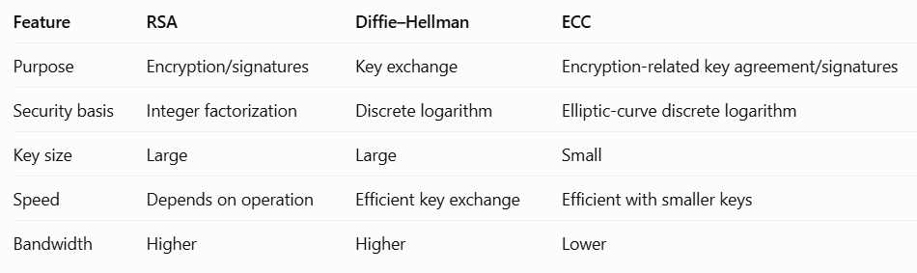5. Security Requirements
- Use secure random number generation.
- Validate public parameters.
- Protect private keys.
- Use trusted cryptographic libraries.
- Follow secure key-management practices.
6. Recommendation
ECC is recommended for remote medical devices because it provides strong security with smaller keys and lower communication overhead.
For example, elliptic-curve Diffie–Hellman (ECDH) can be used to establish session keys.
Result: ECC is suitable for constrained healthcare devices because it reduces key size and communication overhead.

Q6. Digital Signatures, Hybrid Encryption and Quantum-Cryptography Readiness
1. Introduction
Digital signatures verify the sender's identity and ensure that data has not been modified. Hybrid encryption combines symmetric and public-key encryption.
2. Digital Signature Process
Digital signatures provide:
- Authentication
- Integrity
- Non-repudiation
Signing Process:
- Sender prepares the message.
- A hash value is generated.
- Sender signs the hash using their private key.
- Message and signature are sent to the receiver.
Verification Process:
- Receiver receives the message and signature.
- Receiver calculates the message hash.
- Receiver verifies the signature using the sender's public key.
- If the values match, the signature is valid.
3. Comparison of Digital Signature Algorithms
Algorithm | Key Type | Main Feature
RSA | Public and private keys | Uses modular arithmetic.
DSA/DSS | Public and private keys | Designed for digital signatures.
ECDSA | Elliptic-curve keys | Provides smaller keys.
4. Hybrid Encryption
Hybrid encryption combines symmetric and asymmetric encryption.
Working:
- Generate a random symmetric session key.
- Encrypt the healthcare file using AES.
- Protect the session key using RSA or establish it using Diffie–Hellman.
- Authenticate the exchange using digital signatures.
- Receiver obtains the session key and decrypts the file.
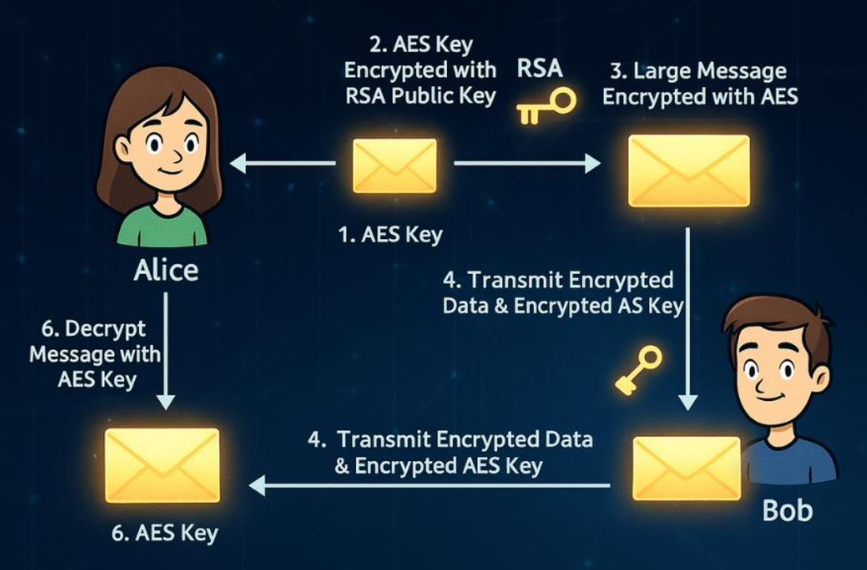
5. Tampering Tests
Test | Expected Result
Modify the file | Hash verification fails.
Modify the signature | Signature verification fails.
Modify the protected session key | Decryption or authentication fails.
6. Direct RSA vs Hybrid Encryption
Feature | Direct RSA | Hybrid Encryption
Large file encryption | Not suitable | Suitable
Speed | Slow | Fast
Key usage | RSA for data | AES for data, public-key method for session key
File handling | RSA size restrictions | Supports large files
7. Quantum Cryptography
Quantum cryptography uses principles of quantum mechanics to protect communication.
Quantum Key Distribution (QKD):
- Uses quantum states to exchange key information.
- Eavesdropping can disturb quantum states.
- The communicating users can detect possible interception.
8. Quantum Computing Threats
Powerful quantum computers may break traditional RSA and ECC using Shor's algorithm.
Migration Plan:
- Identify systems using RSA and ECC.
- Study and implement post-quantum cryptographic algorithms.
- Test hybrid classical and post-quantum key establishment.
- Upgrade certificates and security protocols.
- Regularly review cryptographic security.
QKD can help establish keys in suitable networks, but it does not replace authentication, endpoint security or ordinary key management.
9. Recommendation
Use AES-GCM for large healthcare files, authenticated key establishment for session keys and digital signatures for authentication.
Result: Hybrid encryption provides efficient and secure healthcare file transfer with confidentiality, integrity and authentication.

Q7. Diagnose, Redesign and Validate the Complete Cryptographic Strategy
A. Diagnose the Bottleneck or Weakness
The main weakness in the original healthcare network is the use of RSA for encrypting large files and unauthenticated Diffie–Hellman for key exchange.
Problems:
- RSA encryption is slow for large files.
- Unauthenticated Diffie–Hellman is vulnerable to man-in-the-middle attacks.
- Weak keys can reduce security.
- Reusing encryption nonces can expose information.
B. Define the Design Objective
The objective is to improve security and reduce encryption time by using symmetric encryption for large files and authenticated public-key key exchange.
C. Design the Revised Strategy
The redesigned healthcare architecture uses the following techniques:
Component | Selected Algorithm | Purpose
Data encryption | AES-GCM | Protect medical records
Key exchange | ECDH | Establish session keys
Authentication | Digital signatures | Verify sender identity
Hashing | SHA-256 | Check data integrity
Key management | Secure key storage | Protect secret keys
Working Procedure:
- Hospital and clinics authenticate each other using digital certificates.
- They establish a shared secret using authenticated ECDH.
- A session key is derived from the shared secret.
- AES-GCM encrypts large medical files.
- Digital signatures verify important messages.
- The receiver decrypts and verifies the received data.
D. Integrate Quantum Readiness
Quantum computers may threaten RSA and ECC.
The healthcare network should:
- Identify RSA and ECC usage.
- Prepare to adopt post-quantum cryptography.
- Test hybrid post-quantum key exchange.
- Upgrade cryptographic systems when required.
- Monitor future security developments.
QKD may detect eavesdropping during key distribution, but it cannot replace normal authentication and key management.
E. Predict, Implement and Validate
Prediction:
The redesigned system should reduce public-key encryption operations and improve large-file transfer performance.
Comparison:
Parameter | Original Design | Redesigned Design
File encryption | RSA | AES-GCM
Key exchange | Unauthenticated DH | Authenticated ECDH
Authentication | Limited | Digital certificates/signatures
Large file performance | Slow | Fast
Integrity | Separate protection required | AES-GCM authentication
Quantum readiness | Limited | Migration plan included
Validation Tests:
- Encrypt and decrypt a healthcare file.
- Modify the encrypted file and check authentication failure.
- Test an unauthenticated key exchange to demonstrate MITM.
- Test authenticated key exchange.
- Verify digital signatures.
- Compare the number of public-key and symmetric encryption operations.
Expected Result: The redesigned architecture should provide better performance and protection. Actual timing and operation counts must be recorded by running the implementation.
F. Defend the Final Design
The redesigned architecture is better because:
- AES-GCM provides fast encryption for large files.
- ECDH reduces public-key communication overhead.
- Digital certificates prevent unauthorized communication.
- Digital signatures provide authentication and integrity verification.
- Secure key management protects private and session keys.
- Post-quantum migration planning prepares the network for future threats.
Residual Risks:
- Private-key compromise.
- Incorrect nonce reuse.
- Weak random number generation.
- Implementation errors.
- Future quantum computing attacks.
Final Result: The redesigned healthcare network provides efficient encryption, secure key exchange, authentication and protection against future cryptographic threats.

